**TECHNICAL PROJECT REPORT**

# **Title of Invention / Project:** **Automatic Alert Via Bluetooth With Buzzer**

***Home monitoring system***

# **Team Members / Inventors:**

|  |  |  |  |  |  |
| --- | --- | --- | --- | --- | --- |
| **S. No.** | **Name** | **Department** | **Designation** | **Mobile** | **E-Mail** |
| 1. | Raghav Goel | CSE | Student | 8168127644 | raghavgoel847@gmail.com |
| 2. | Varnika Sharma | CSE | Student | 9654315567 | varnika.sharma1801@gmail.com |
| 3. | Vanshita Manral | CSE | Student | 8146858558 | manral.14vanshita@gmail.com |
| 4. | Vanshika Sanan | CSE | Student | 7831084984 | sanan.vanshika@gmail.com |
| 5. | Khushal Thakur | ECE | Mentor | 9646030764 | khushal.thakur@cumail.in |
| 6. | Anshul Sharma | ECE | Mentor | 9478697475 | anshulsharma.ece@cumail.in |
| 7. | Kiran Jot Singh | ECE | Mentor | 9463909689 | kiranjotsingh.ece@cumal.in |
| 8. | Divneet Singh Kapoor | ECE | Mentor | 9878422653 | divneet.ece@cumail.in |

Section – 1 (IPR Related)

# **Abstract:**

* **Problem your project is solving?**

Security is one of the major concerns in everyone’s life, and therefore surveillance is important.

We can check or monitor our house on a full-time basis, we can check whether someone is lurking around our house.

* **How are you solving that?**

We have built a **smart door sensing device** using Arduino which can easily sense and detect a person coming near the door in certain detection distance and will ring the buzzer in the given range. Our system will also send an intruder alert to a connected mobile phone via Bluetooth, which can make the person alert that someone is there at his\her place.

* **Additional modifications that can cater to improved solution.**
* For the additional modification we can attach a camera/ surveillance which will send photos of our guest.
* We can also install an intercommunication system which will enable us to identify and record the voice of the intruder.
* We can give a notification or alert with the help of wireless WIFI (esp2866) module via mail system.

# **Existing state-of-the-art and Drawbacks in existing state-of-the-art**

|  |  |  |
| --- | --- | --- |
| **S. No.** | **Existing state of art** | **Drawbacks in existing state of art** |
| 1 | **Suspicious individual detector**  https://patents.google.com/patent/KR101492506B1/en?q=home&q=monitoring&q=security&q=system&q=via&q=bluetooth&q=alert&q=buzzer&oq=home+monitoring+security+system+via+bluetooth+alert+and+buzzer | It gives false alerts many times and is expensive. |
| 2 | **Monitoring device, monitoring system, monitoring method and program.**  https://patents.google.com/patent/KR101492506B1/en?q=home&q=monitoring&q=security&q=system&q=via&q=bluetooth&q=alert&q=buzzer&oq=home+monitoring+security+system+via+bluetooth+alert+and+buzzer | The response time is slower comparatively. |

# **Novel/Additional modifications that you can propose to improve upon drawbacks**

* **Feature 1**

We can use camera or surveillance instead of alerts and install a sound system to hear voices.

* **Feature 2**

We can use wi-fi module instead of bluetooth module, as bluetooth is short ranged.

# **Advantages**

* **Adv 1**

Its is deterrent to the crime.

* **Adv 2**

It allows to have a remote access to your home.

* **Adv 3**

Low maintenance cost and can be easily executed.

* **Adv 4**

Prevents unknown intrusion attempts.

# **Block Diagram**

SMART PHONE

Section – 2

(Real Project)

# **Materials**

* **Battery with cap**

**Description:**

**Voltage= 9 volts**

**Non- rechargeable**

**Used for- toys, watch, etc**

* **Arduino UNO**

**Microcontroller-ATmega328**

**Operating voltage- 5V**

**Input voltage- 7-12V**

**Input voltage- 6-20V**

**Digital I/O pins 14 (6 of which provide PWM)**

**Analog Input pins- 6**

* **Breadboard**

**Description:**

**400 tie points**

**2 Power Lanes, Tie-pints 100**

**1 Double-strip, Tie-points 300**

**Size- 8.2* 5.5* 0.85 cm**

**Voltage/current- 300V/3-5A**

* **Ultrasonic Sensor**

**Working voltage: 5V (dc)**

**Static current: less than 2 mA**

**Output signal: electrical frequency signal,**

**High level 5V, low level 0V**

**Sensor angle: less than 15 degrees**

**Detection distance: 2cm-450cm**

* **Alarm/Buzzer**

**B20 buzzer**

**Piezoelectric 3-12V**

**Used in: bikes, electronics circuit**

* **Jumper Wires**

**Wire length: 20cm**

**The male ends meant for insertion into standard**

**0.1inch female socket**

**The female ends are meant for insertion onto standard**

**0.1inch male headers**

* **Bluetooth module- HC-05**

# **Circuit Diagram**

# 

# **Steps of Circuit Completion:**

The pictures of the different stages in the circuit are as follows –

**Bluetooth hc-05**

* The Buzzer long leg (+) connect to the Arduino Board Digital 11
* The Buzzer short leg (-) connect to the Arduino Board GND
* The HC-SR04 Ultrasonic Module has 4 pins, Ground, VCC, Trig and Echo. The Ground and the VCC pins of the module needs to be connected to the Ground and the 5 volts pins on the Arduino Board respectively and the trig and echo pins to any Digital I/O pin on the Arduino Board.
* The HC-SR04 sensor attach to the Breadboard
* The Sensor VCC connect to the Arduino Board +5V
* The Sensor GND connect to the Arduino Board GND
* The Sensor Trig connect to the Arduino Board Digital I/O 9
* The Sensor Echo connect to the Arduino Board Digital I/O 10

**Bluetooth:**

* TX OF BLUETOOTH TO RX OF ARDUINO
* RX OF BLUETOOTH TO TX OF ARDUINO
* VCC TO BATTERY
* GND TO GND

**The picture of Phase 1 of the circuit –**

**First Phase of Connection**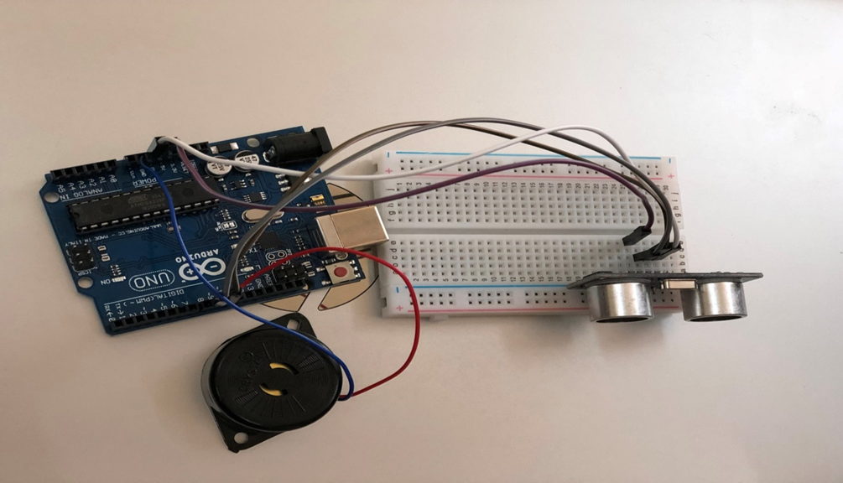

# **Second Phase of Connection**

# 

**Final Phase of the circuits**

# **Program Code**

***https://github.com/vanshitamanral/home-monitoring-system***